WASP Pellet Extruder

**Basic datas :**

Dimensions :

Weight :

**Components :**

Stepper Motor : Pamoco P85 - 2H - 2 - B - 200 - 4 - A14* = 2A, 80 to 150VDC

Heating Ring : 220 VAC, ??? A

Thermocouple : Type J + AD 596 board ( Vout = 10 mV/°C × (Temp in °C)).

Fans : 12VDC

**Connectors**

4 Big for the motor phase

2 Big for the heating system

3 small for 24 V (1 for the top fan, 1 for the 6 bottom fans, 1 pin for common ground)

1 small for Thermistor

2 small for Kuka iiwa

**Thermistor issue :**

RJ48 with pins 4,5,6 = RJ45 with pins 3,4,5

Flipped RJ48 Ethernet plug

(GND = 4 = white/blue ; Power 12V = 5 = blue; ThermoCouple = 6 = white/green )

RJ48 Ethernet wire

(GND = 3 = green; Power 12V =4 =blue; ThermoCouple = 5 =white/blue )

Flipped RJ45 Ethernet wire

(GND = 4 = blue; Power 12V =5 =white/blue; ThermoCouple = 6 =green ) => fixed 0.8 V

RJ45 Ethernet wire

(GND = 3 = white/green ; Power 12V = 4 =blue; ThermoCouple = 5 = white/blue) => fixed 13.8 V

RJ45 Ethernet wire

(GND = 3 = white/green ; Power 12V = 4 =blue; ThermoCouple = 5 = green) => fixed 14.8 V

Strange

(GND = 3 = blue ; Power 12V = 4 =white/green; ThermoCouple = 5 = white/blue)

Random

(GND = 3 = blue ; Power 12V = 4 =white/green; ThermoCouple = any

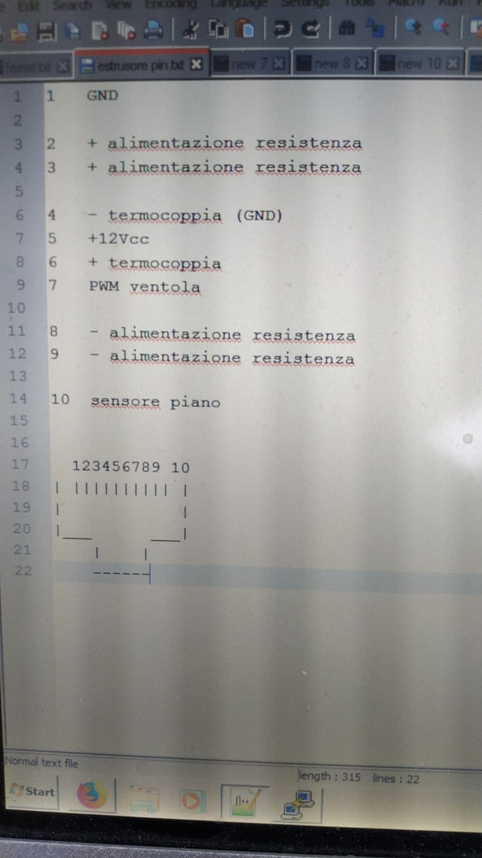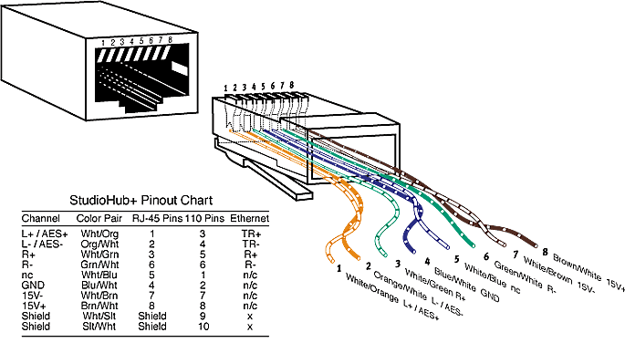

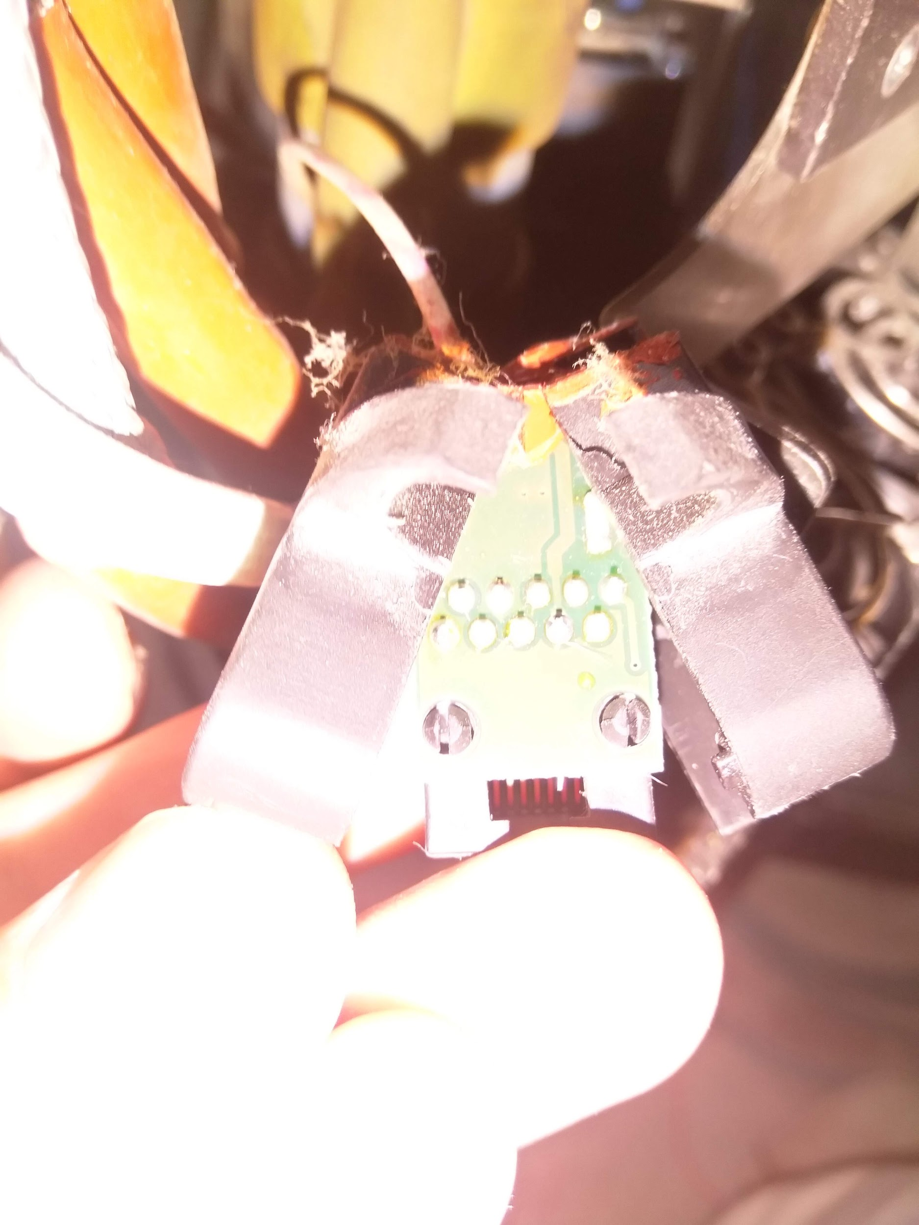 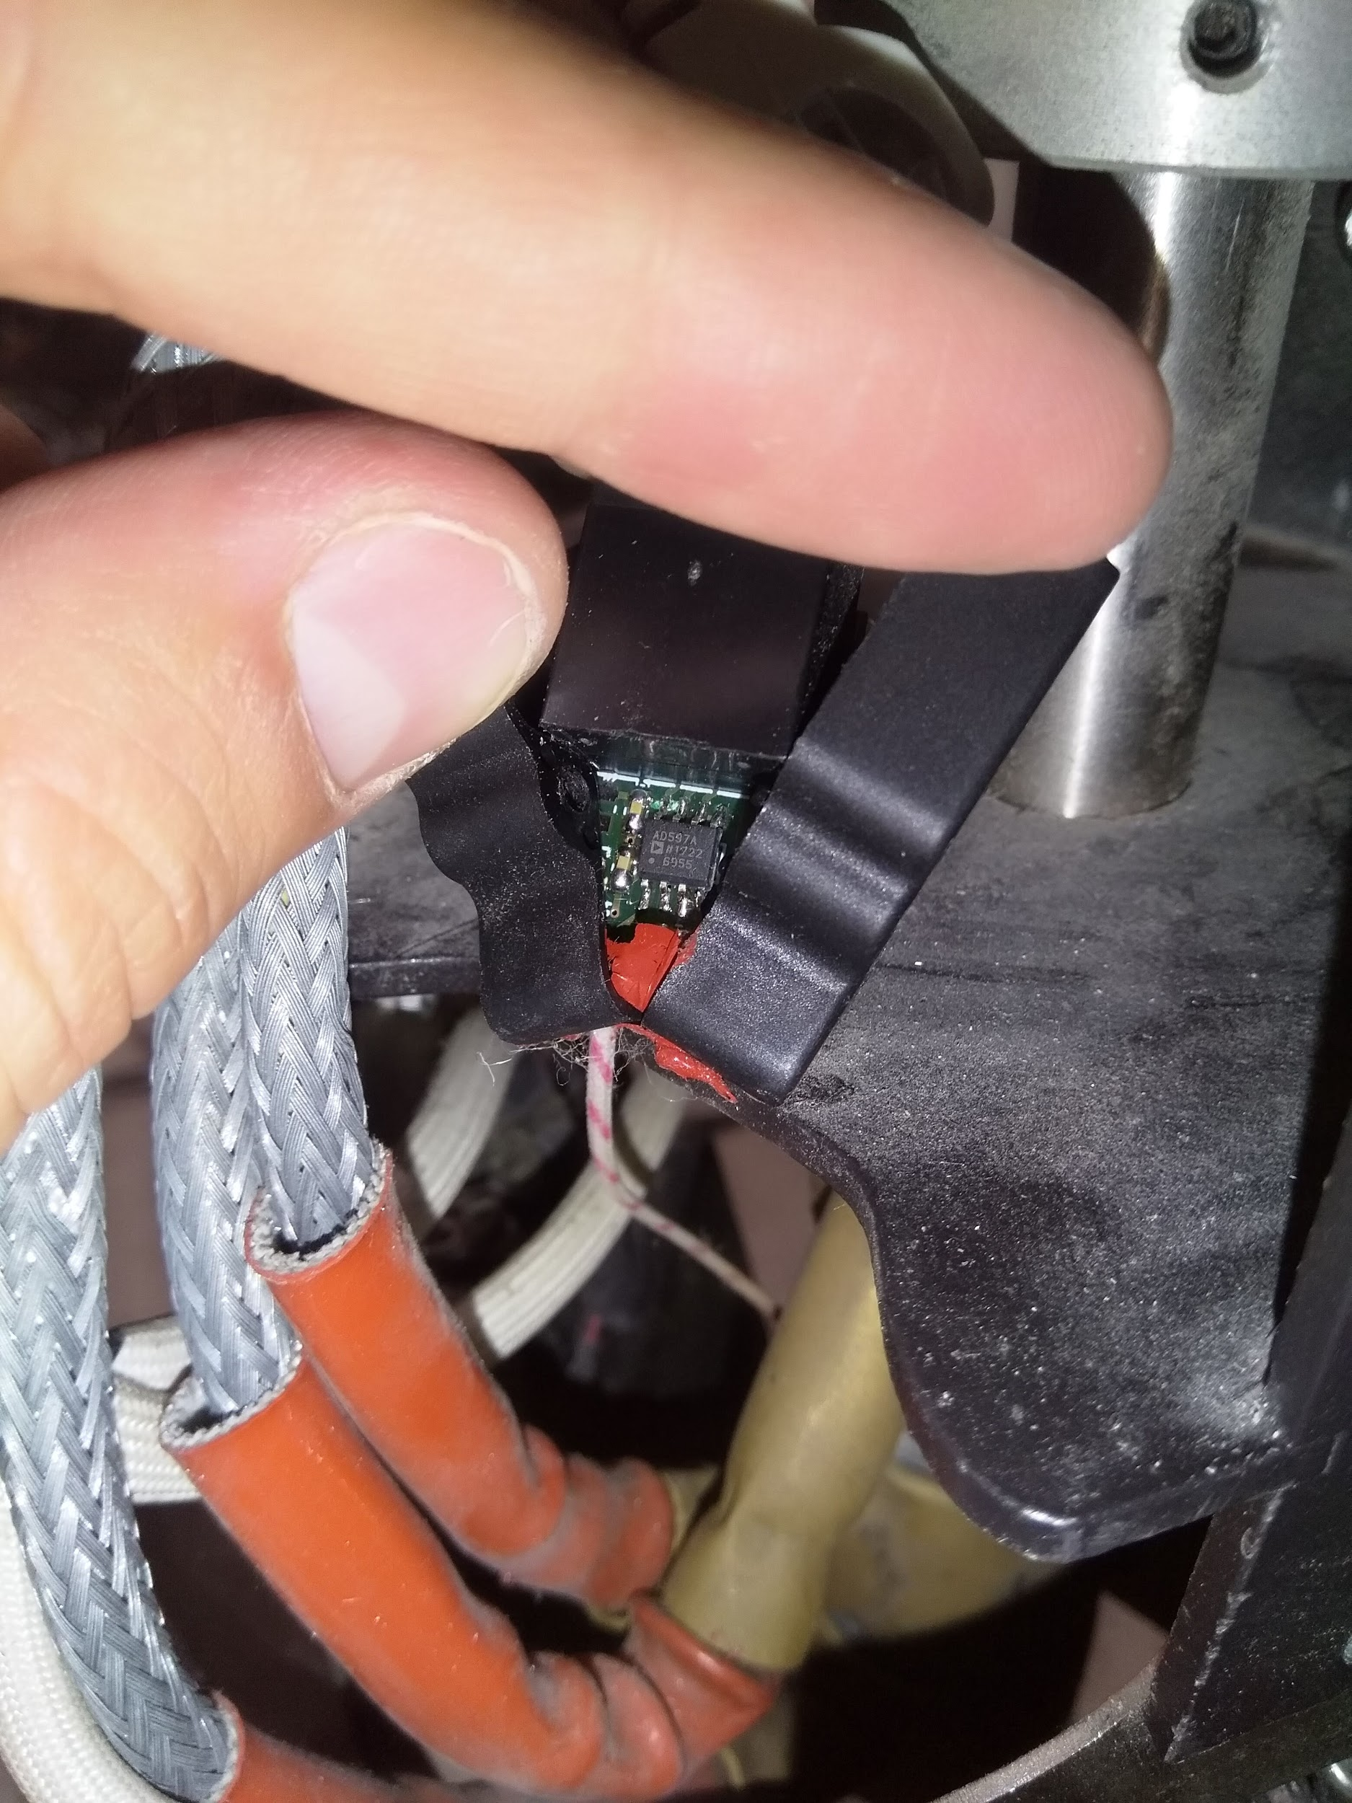

To buy :

* Cable wrapper 5m
* Cable scracth
* Ethernet connector to cut
* M8 to free cable, with 8 core

To do :